PHASE-1

PROPOSED SOLUTION

BY
M.MAHESWARI
952319104023

Proposed Solution

Having hooked your audience into the problem, now you want to paint a picture of what the world will be like when you solve the problem. Your proposed solution should relate the current situation to a desired result and describe the benefits that will accrue when the desired result is achieved. So, begin your proposed solution by briefly describing this desired result.
- Problem-Solution essays (or, as they may also be referred to, Proposing Solutions or Proposal essays) serve an important role. These essays inform readers about problems and suggest actions that could be taken to remedy these problems. People write proposals every day in business, government, education, and other professions. Proposals are a basic ingredient of the world’s work.

Novelty Solutions
“Novelty Solutions”, was incorporated in 2016, as a wholesale trader of a wide range of Biometric Attendance System, CCTV Camera, Safe Locker and many more. We are expertise in this domain for offering premium quality products and services. Our offered product and service is broadly appreciated among our respected customers for their features such as longer service life, impeccable finish and low maintenance.



FEASIBILITY OF IDE
Economic Feasibility :

- State Government in order to promote solar energy provides a tax-free subsidy for $1.25 million on initial capital investment.
- The equipment cost at the beginning of the project will be $17.5 million. The project also requires some additional equipment at the end of the third year for
$1.25 million.

- The total life of the original equipment is 8 years with zero resale/
- sales volume over the 8 year period is:-

- Solutiod n:

- Solar Electricity Project – Tesla Ltd

- Statement of Initial Cash Outflow

BUSINESS MODEL

Marketing Plan
Within a marketing plan, a company must establish their Value Proposition, Brand, and Target Market.
. We will market to companies who are interested in embedding their brand and offers inside our games. We will also target those who would like something more custom to offer as their own game. In the first 3 years of the business, we expect consulting to constitute a large portion of our revenue stream.
We will attract clients using the top SEO ranking factors and SEO strategies.

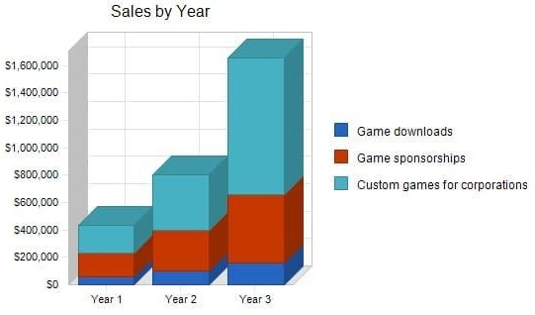

Objectives
- Generate over $400,000 in sales by the end of year 1.
- Increase sales by 100% by the end of year 2. 3.Land 4 custom consulting game
development projects within 12 months

SOCIAL IMPACT

Social impact is a positive change on people and the planet better understood through a well-designed theory of change designed to
improve the outcome. Social impact has been historically been around in the form of philanthropy for many decades. In 1972 Bill Drayton, the father of social enterprise started a new movement that gave rise to a
new social impact approach. There is a social impact revolution is taking place and COVID-19 now has accelerated this trend by putting pressure on businesses, impact investors, and philanthropy.
POSITIVE IMPACT
NEGATIVE IMPACT
  - Persistently lower wages for a worker without healthcare insurance
  - Increased pollution in city or ocean

  - Persistent social isolation due to mental illness

  - Long term refugees

SCALABILITY OF SOLUTION

Scalability refers to the ability of an organization (or a system, such as a computer network) to perform well under an increased or expanding workload. A system that scales well will be able to maintain or increase its level of performance even as it is tested by larger and there are two basic types of scalability in cloud computing: vertical and horizontal scaling

